1. Let’s install Docker to get a better idea.  
   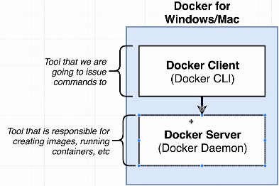
2. We’re going to install Docker based on our OS inside of which, there are two important tools that we’re going to be making use of throughout this course.
   1. **Docker Client**: Also known as **Docker CLI**. This is the main tool with which we’re going to interact a lot. We interact with this through terminal. We give command there and that command goes to Docker CLI and then CLI figures out what to do with this. Actually CLI doesn’t do anything on its own with container or images. Actually, Docker CLI is a piece of software inside Docker which helps us to interact with **Docker Server**.
   2. **Docker Server**: Actual piece of software that is responsible for creating containers, images and maintaining containers, uploading and downloading images.
3. 